**EzAutomator**

**MANUAL**

**C:\Program Files\Microsoft Office\MEDIA\CAGCAT10\j0215086.wmf**

There are currently three different actions available: “Click on specified coordinates”, “Send Keys” and “Confirmation”. Each action has its own unique role in the program and can be used to automate many tedious and time-consuming procedures.

**Click on the screen**

**Available Actions**

**How to make the program click on the screen**

“Click on specified coordinates” – Makes the script click or hover over using the mouse on a desired point (X and Y coordinates) on the screen that you may specify. This point can contain a button, an app or anything else, really. As an example, here I will make the program open the recycle bin:

1. First of all, you may select the first action from the yellow drop down menu, like so:

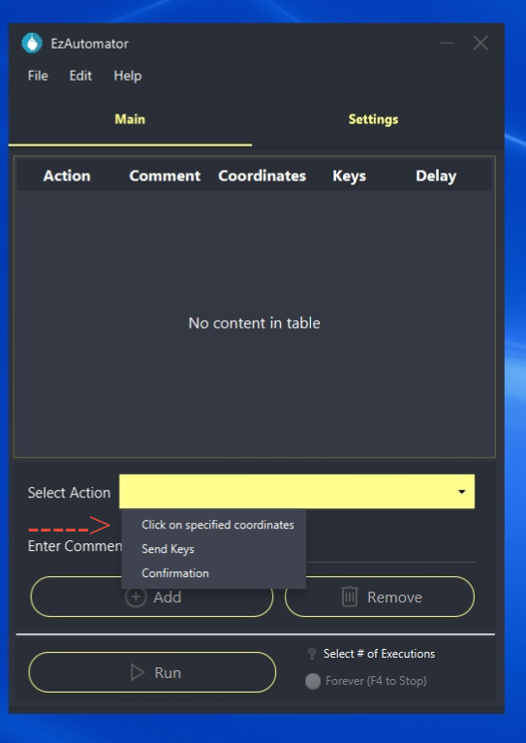

1. After doing so, a new window will pop-up where you will be able to capture the point on the screen. To capture the point, you may click “Capture”, or press F1 alternatively to start capturing the point. 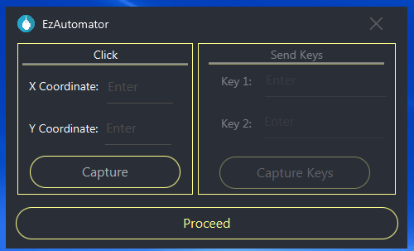

Then, move the mouse to the desired location on the screen, and click F2 to confirm the selection.

Once you click F2, you will need to verify that the numbers in the left tab stop changing, and confirm the action by pressing “Proceed”.

